AD9910 Test Log

**Contents**

1. Evaluation Board Test

1.1. Verilog Code Modification

1.2. Python Code

1.3. Implementation

2. New Design

2.1. Modified Architecture

2.2. Modified Function

2.3. Simulation on Verilog

2.4. Test on AD9910 evaluation board

1. Evaluation Board Test

1.1. Verilog Code Modification

To test AD9910 evaluation board, AD9912 verilog code was modified. AD9912's block diagram is shown in below figure. There is FSM which control input from serial port and WRT, but it is skipped here.



Figure.1



Figure.2



Figure.3



Figure.4



Figure.5

First modification in code is that 'DDS1_powerdown', 'DDS2_powerdown' wires in 'AD9912_DAC8734.sv' were replaced to 'DDS1_ioupdate', 'DDS2_ioupdate' logics which would make 60ns(6 clock cycle) pulse at ja_7 and ja_0 pins. 'DDS1_powerdown', 'DDS2_powerdown' were discharging only LOW signal in previous AD9912 Verilog code. Second, FSM state 'MAIN_DDS_IOUPDATE_OUT', 'MAIN_DDS_IOUPDATE_END' were added. Addition of IO update signal is made since update of register in AD9912 occurs after IO update pulse. Third, parameter 'DDS_MAX_LENGTH' in same file and 'MAX_LENGTH' in 'WriteToRegister.v' was changed to 9 from 8 due to profile setting which requires 9bytes of signal at once. And some code were added in 'data_receiver_v1_00.v' to initialize logics and "\r", "\n" were replaced to ascii code value in 'TERMINATOR_CURRENT_CHAR_POINTER' conditional part since these made error in simulation.

1.2. Python Code

Python code 'AD9910_eval.py' controls AD9910 evaluation board through FPGA. Same 'Arty_S7_v1_01' library with AD9912 python code('AD9912_DAC8734_v1_01.py') was imported and serial communication protocol is similar between AD9910 and AD9912. However AD9910 uses IO_UPDATE pulse as mentioned to update its register meanwhile AD9912 writing to specific register to update its register. In addition, AD9910 has fixed length for each register, so length of signal is not included in header and longest one is 9bytes including address. On the other hand, AD9912 has mutable length which should be included in header and longest one is 8bytes. Main functions of python code are as below. Notice that these python and verilog code are old version, and new codes are made.

__init__( fpga, min_freq = 10, max_freq = 400, sys_clk = 1000, unit = 'MHz')

AD9910 constructor method has fpga, min_freq, max_freq, sys_clk, unit parameters. fpga is ArtyS7 object, min_freq, max_freq are minimum, maximum output frequency of DDS and sys_clk is reference clock for DDS(PLL is not implemented yet). Unit of frequency is set by unit parameter and default value is 'MHz'. Notice that unit parameter is removed and use different scheme to indicate unit of parameter.

make_header_string(register_address, direction = 'W')

This method makes header string in hexadecimal which is compatible with AD9912's method. But in AD9910 this was not used, and header was made directly in write16, write 32, write64 method.

write16(register_addr, register_data, ch1, ch2)

This method write 16 bit data to DDS register calling send_mode_BTF_int_list, and send_command method in ArtyS7. register_addr is address of register, register_data is register data, and ch1, ch2 indicate whether DDS1, DDS2 would be written.

write32(register_addr, register_data, ch1, ch2)

This method is similar to write16, but write 32 bits to DDS register.

write64(register_addr, register_data, ch1, ch2)

This method is similar to write16, but write 64 bits to register.

frequency_to_FTW(freq, unit = 'MHz')

This method convert frequency to 32 bits FTW which responds to ratio of output frequency and system clock frequency. Unit of frequency is equal to parameter unit and default is 'MHz'.

phase_to_POW(phase, unit = 'FRAC')

This method converts phase to 16 bits POW which is equal to phase of output wave and two pi. Unit of phase is equal to parameter unit and default is 'FRAC'.

amplitude_to_ASF(amplitude_frac)

This method converts fraction between output amplitude and maximum amplitude to 14 bits ASF. There is no unit parameter and only support fraction.

set_frequency(freq, ch1, ch2, unit = 'MHz')

This method sets value in FTW register. Unit of frequency is equal to parameter unit and default is 'MHz', and ch1, ch2 indicate whether DDS1, DDS2 will be written. Note that this method does not change single tone profile register. This register will be used in RAM mode, DRG mode, parallel mode.

set_phase(phase, ch1, ch2, unit = 'FRAC')

This method sets value in POW register. Unit of phase is equal to parameter unit and default is 'FRAC', and ch1, ch2 indicate whether DDS1, DDS2 will be written. Note that this method does not change single tone profile register. This register will be used in RAM mode, DRG mode, parallel mode.

set_amplitude(amplitude_frac, ch1, ch2)

This method sets value in ASF register. ch1, ch2 indicate whether DDS1, DDS2 will be written. Note that this method does not change single tone profile register. This register will be used in RAM mode, DRG mode, parallel mode.

initialize()

This method initialize CFR register of DDS to use singletone mode using set_CFR1(), set_CFR2(), set_CFR3() method.

set_CFR1(...), set_CFR2(...), set_CFR3(...)

This method sets CFR register of DDS as name indicate. It has parameters that which compose CFR register and could be set manually. Each role of parameter can be found in AD9910 manual.

set_profile(freq, phase, amplitude, ch1, ch2, profile = 0, unit_freq = 'MHz', unit_phase = 'FRAC')

This method sets frequency, phase, and amplitude of DDS profile register.

1.3. Implementation

1.3.1. Debugging Output of FPGA board

Bit stream file was uploaded to ArtyS7 board, and output of FPGA was checked by MSO7054 oscilloscope. ja7, ja6, ja5, ja3, and GND pin of ArtyS7 was connected to RIGOL cable and this cable was connected to oscilloscope whose impedance is well matched. To measure output signal of FPGA using oscilloscope, turn on LA port. And there would output signal of FPGA on oscilloscope screen as green lines. Then, set oscilloscope to decode mode, set decode mode to SPI mode and match each source of CSB, MOSI, MISO, SCK with proper cable number. Then set horizontal time interval adequatly. In this case, 1~5us would be sufficient to see SPI signal. Finally push SINGLE button and send signal to FPGA using python program on the computer. Then there would be output of FPGA on the oscilloscope screen. Procedure is as follows.

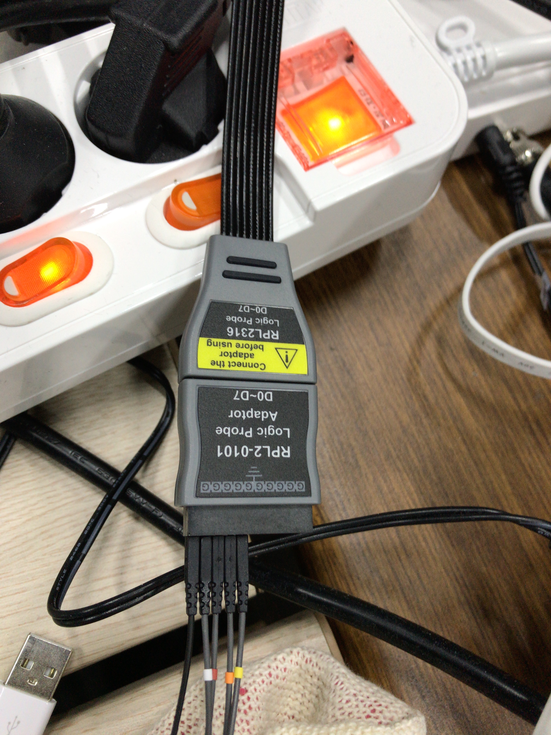

Figure. Connection between FPGA and oscilloscope using RIGOL

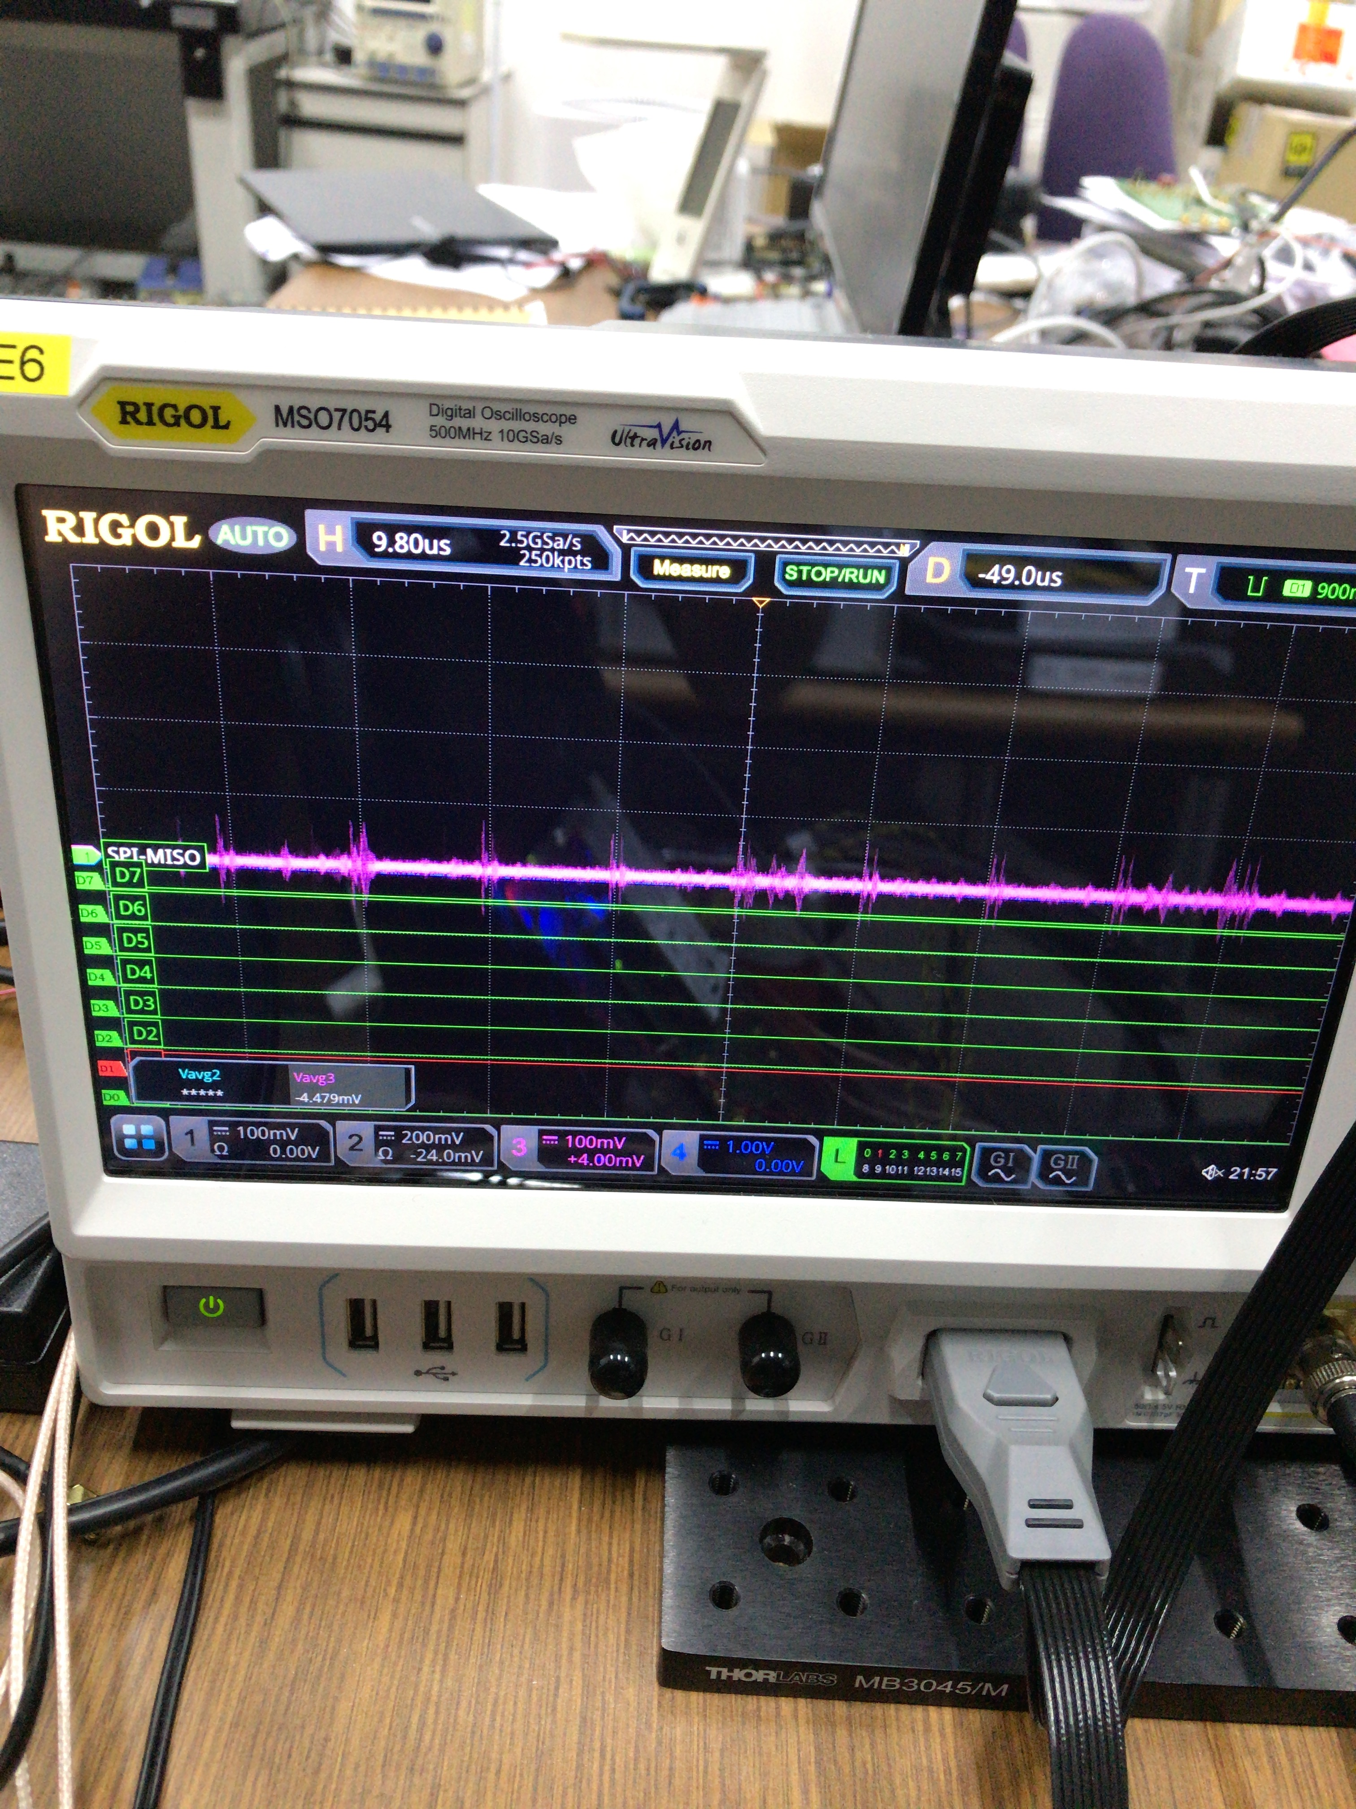

Figure. Green line appears when LA button is pushed

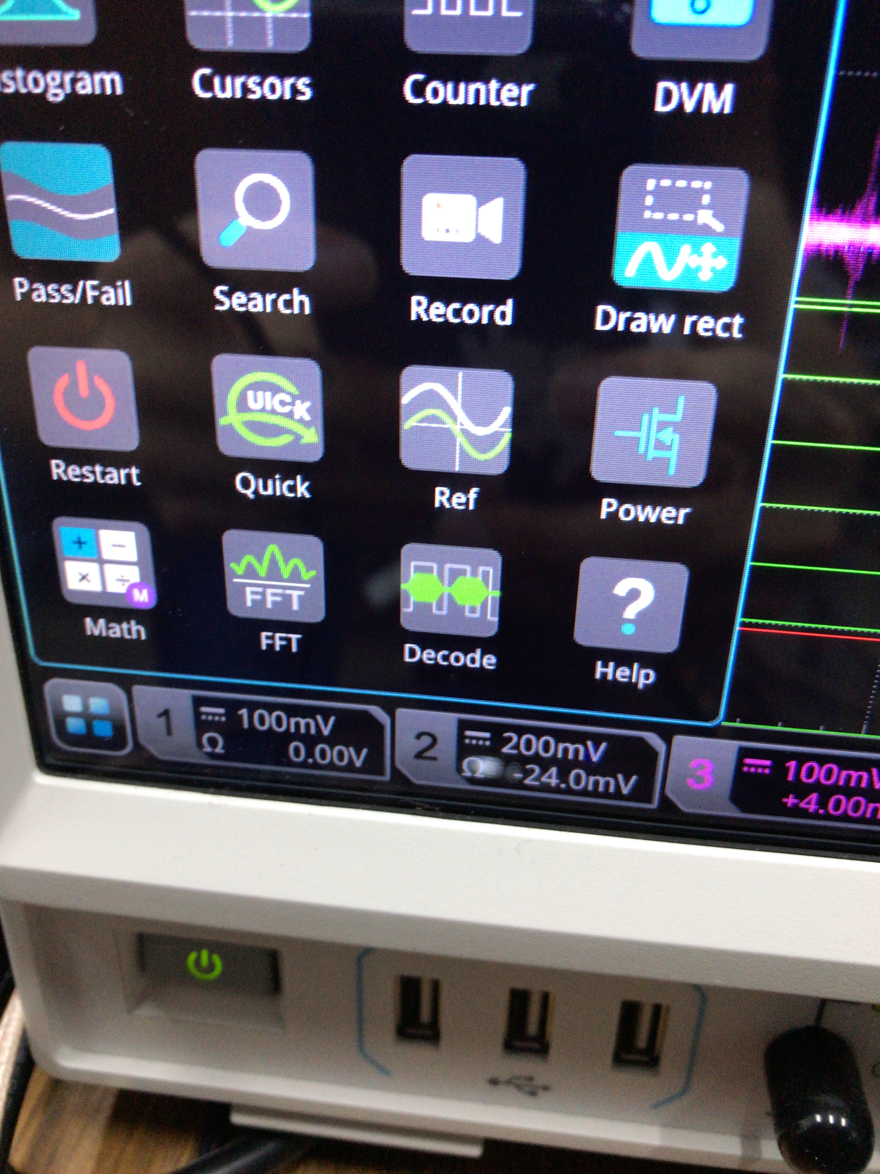

Figure. Decode button will be appear if left below box is selected

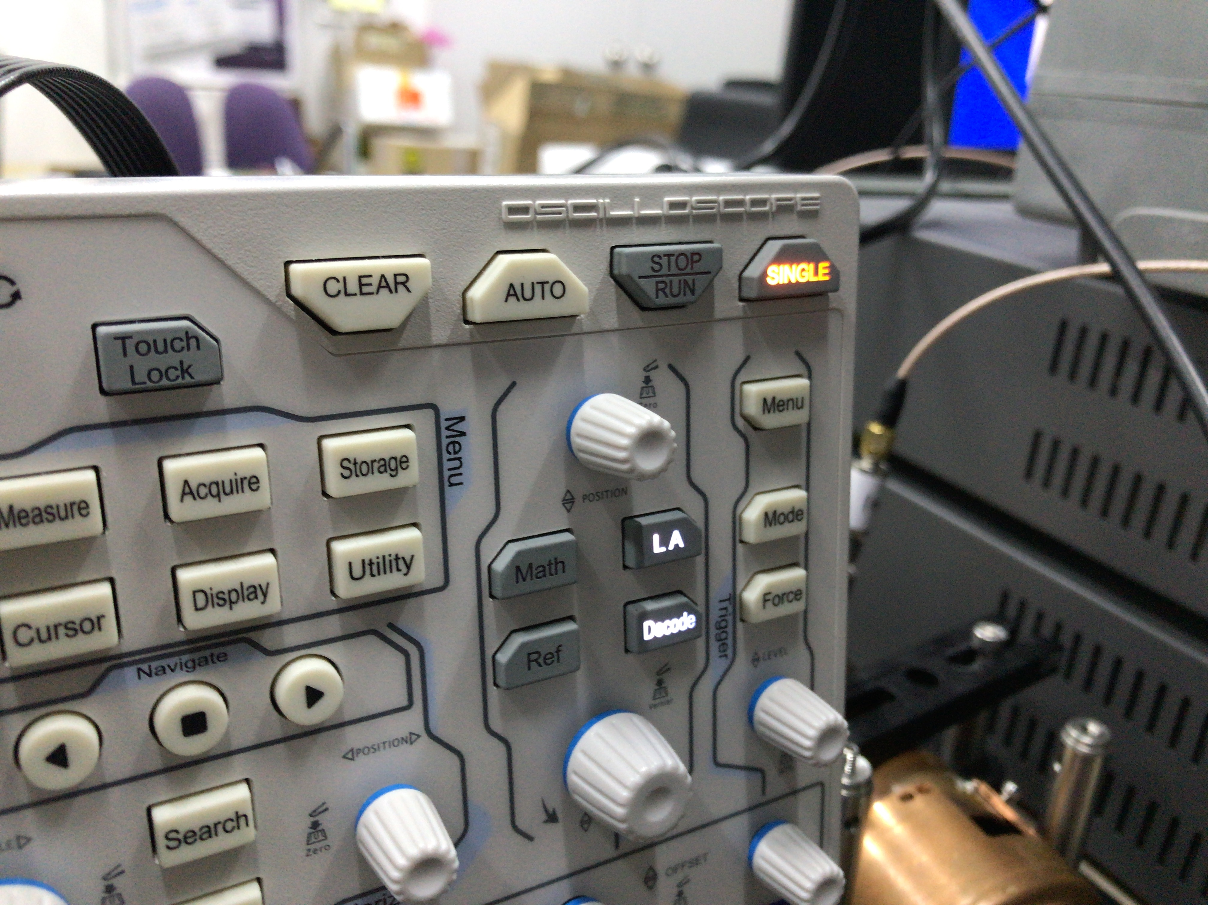

Figure. Push single button before making output from FPGA

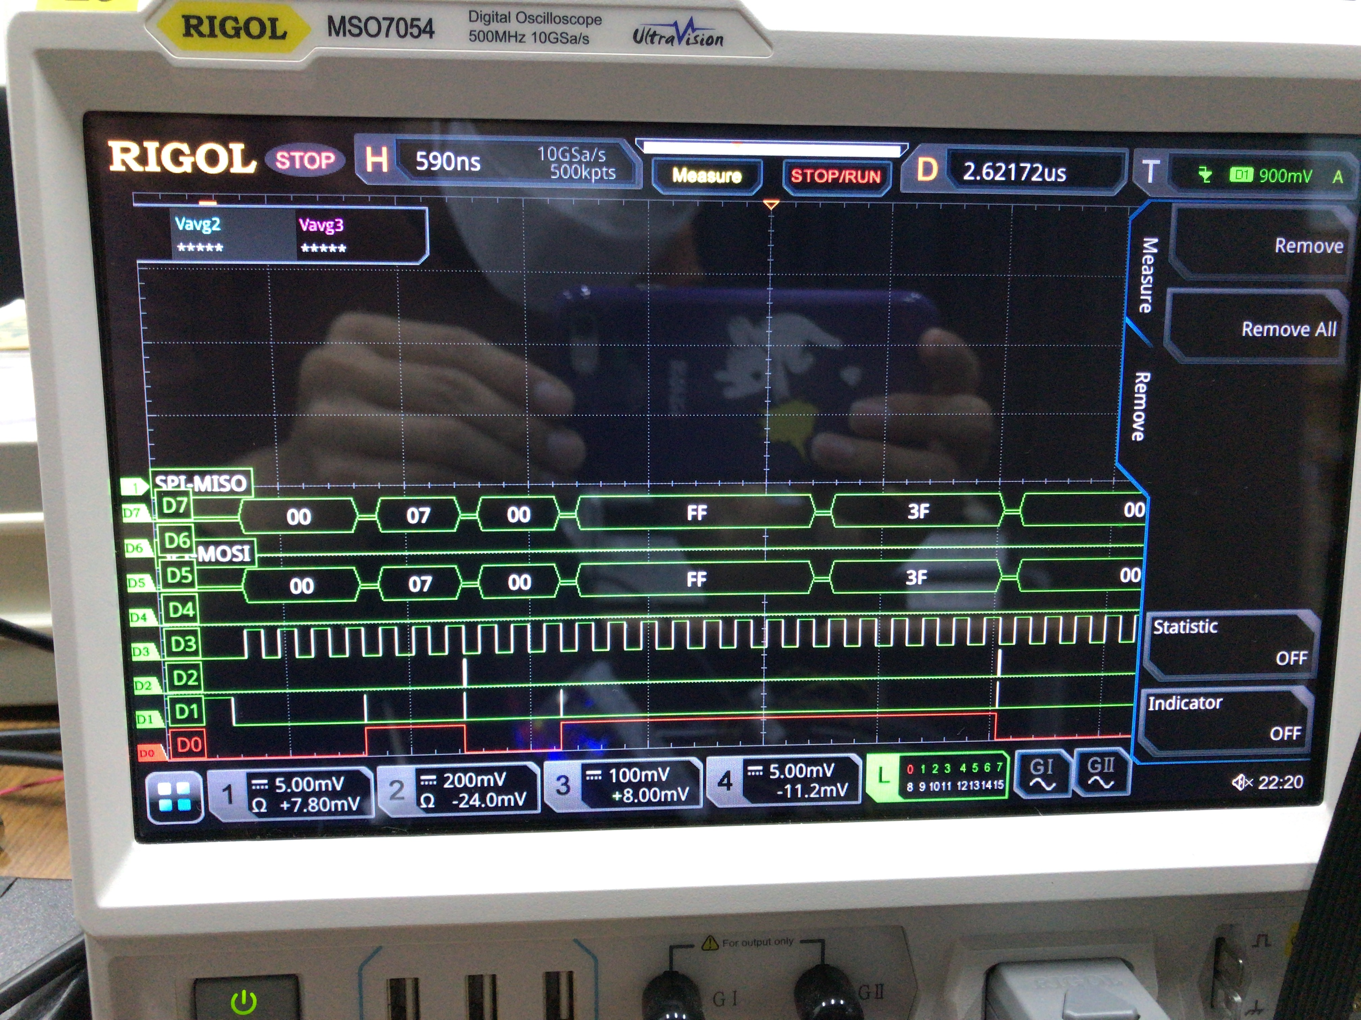

Figure. FPGA output appears on oscilloscop screen

1.3.2. Measurement of DDS Output

1.3.2.1. Using Analog Program

Running DDS board requires signal generator(SG384), DC supply(2230G-30-6). And control of DDS needs connection of computer between board using USB cable, and proper jumper setting on the board. Also measuring waveform of DDS needs oscilloscope(TDS3032B). First set signal generator frequency to 500MHz, and output power bigger than 10.0dBm. Maximum input reference clock of AD9910 is 1GHz, but using Analog program limits it to 500MHz. Then connect output of signal generator to DDS board using SMA to SMA cable. After that, set DC supply output to 1.8V, and 3.3V for each port. Then connect each output and ground port of DC supply with evaluation board properly. Voltage requirement and ground is written on evaluation board. Connecting each port separately, or using ferrite bead is demanded for more precise waveform. However purpose of this test is just checking functionality of DDS so it was not considered. Then set jumper W1, W2, W4 on the evaluation board to enable, and place jumper W5, W6, W3( in other word, make connection of two pins located at that jumper port). And set W7 to REF_CLK(since signal generator is used for reference clock) and W11 pin to middle(since TxE pin was not used in this case). And connect DDS board to PC, then you can see VBUS led being flahsed in red, and USB led being blinking in yellow. If not, connection and instrument setting should be checked again. Then turn on AD9910 program on the computer. If program is not installed, you can find it in Google easily. After program is turned on there would be two green bar left below of program. In this case external clock should be set to 500MHz since input of reference is equal to 500MHz. Then connect FILTERED_IOUT to oscilloscope using SMA to BNC cable. To see simple waveform set profile0 output frequency to 200MHz, phase offset to 0 DEG and push LOAD button on the Analog program. Notice that Enable Multiplier, Power Down should not be set to high. In addition if IO UPDATE option is not set to Auto, it requires to send IO UPDATE signal manually to update register of DDS.

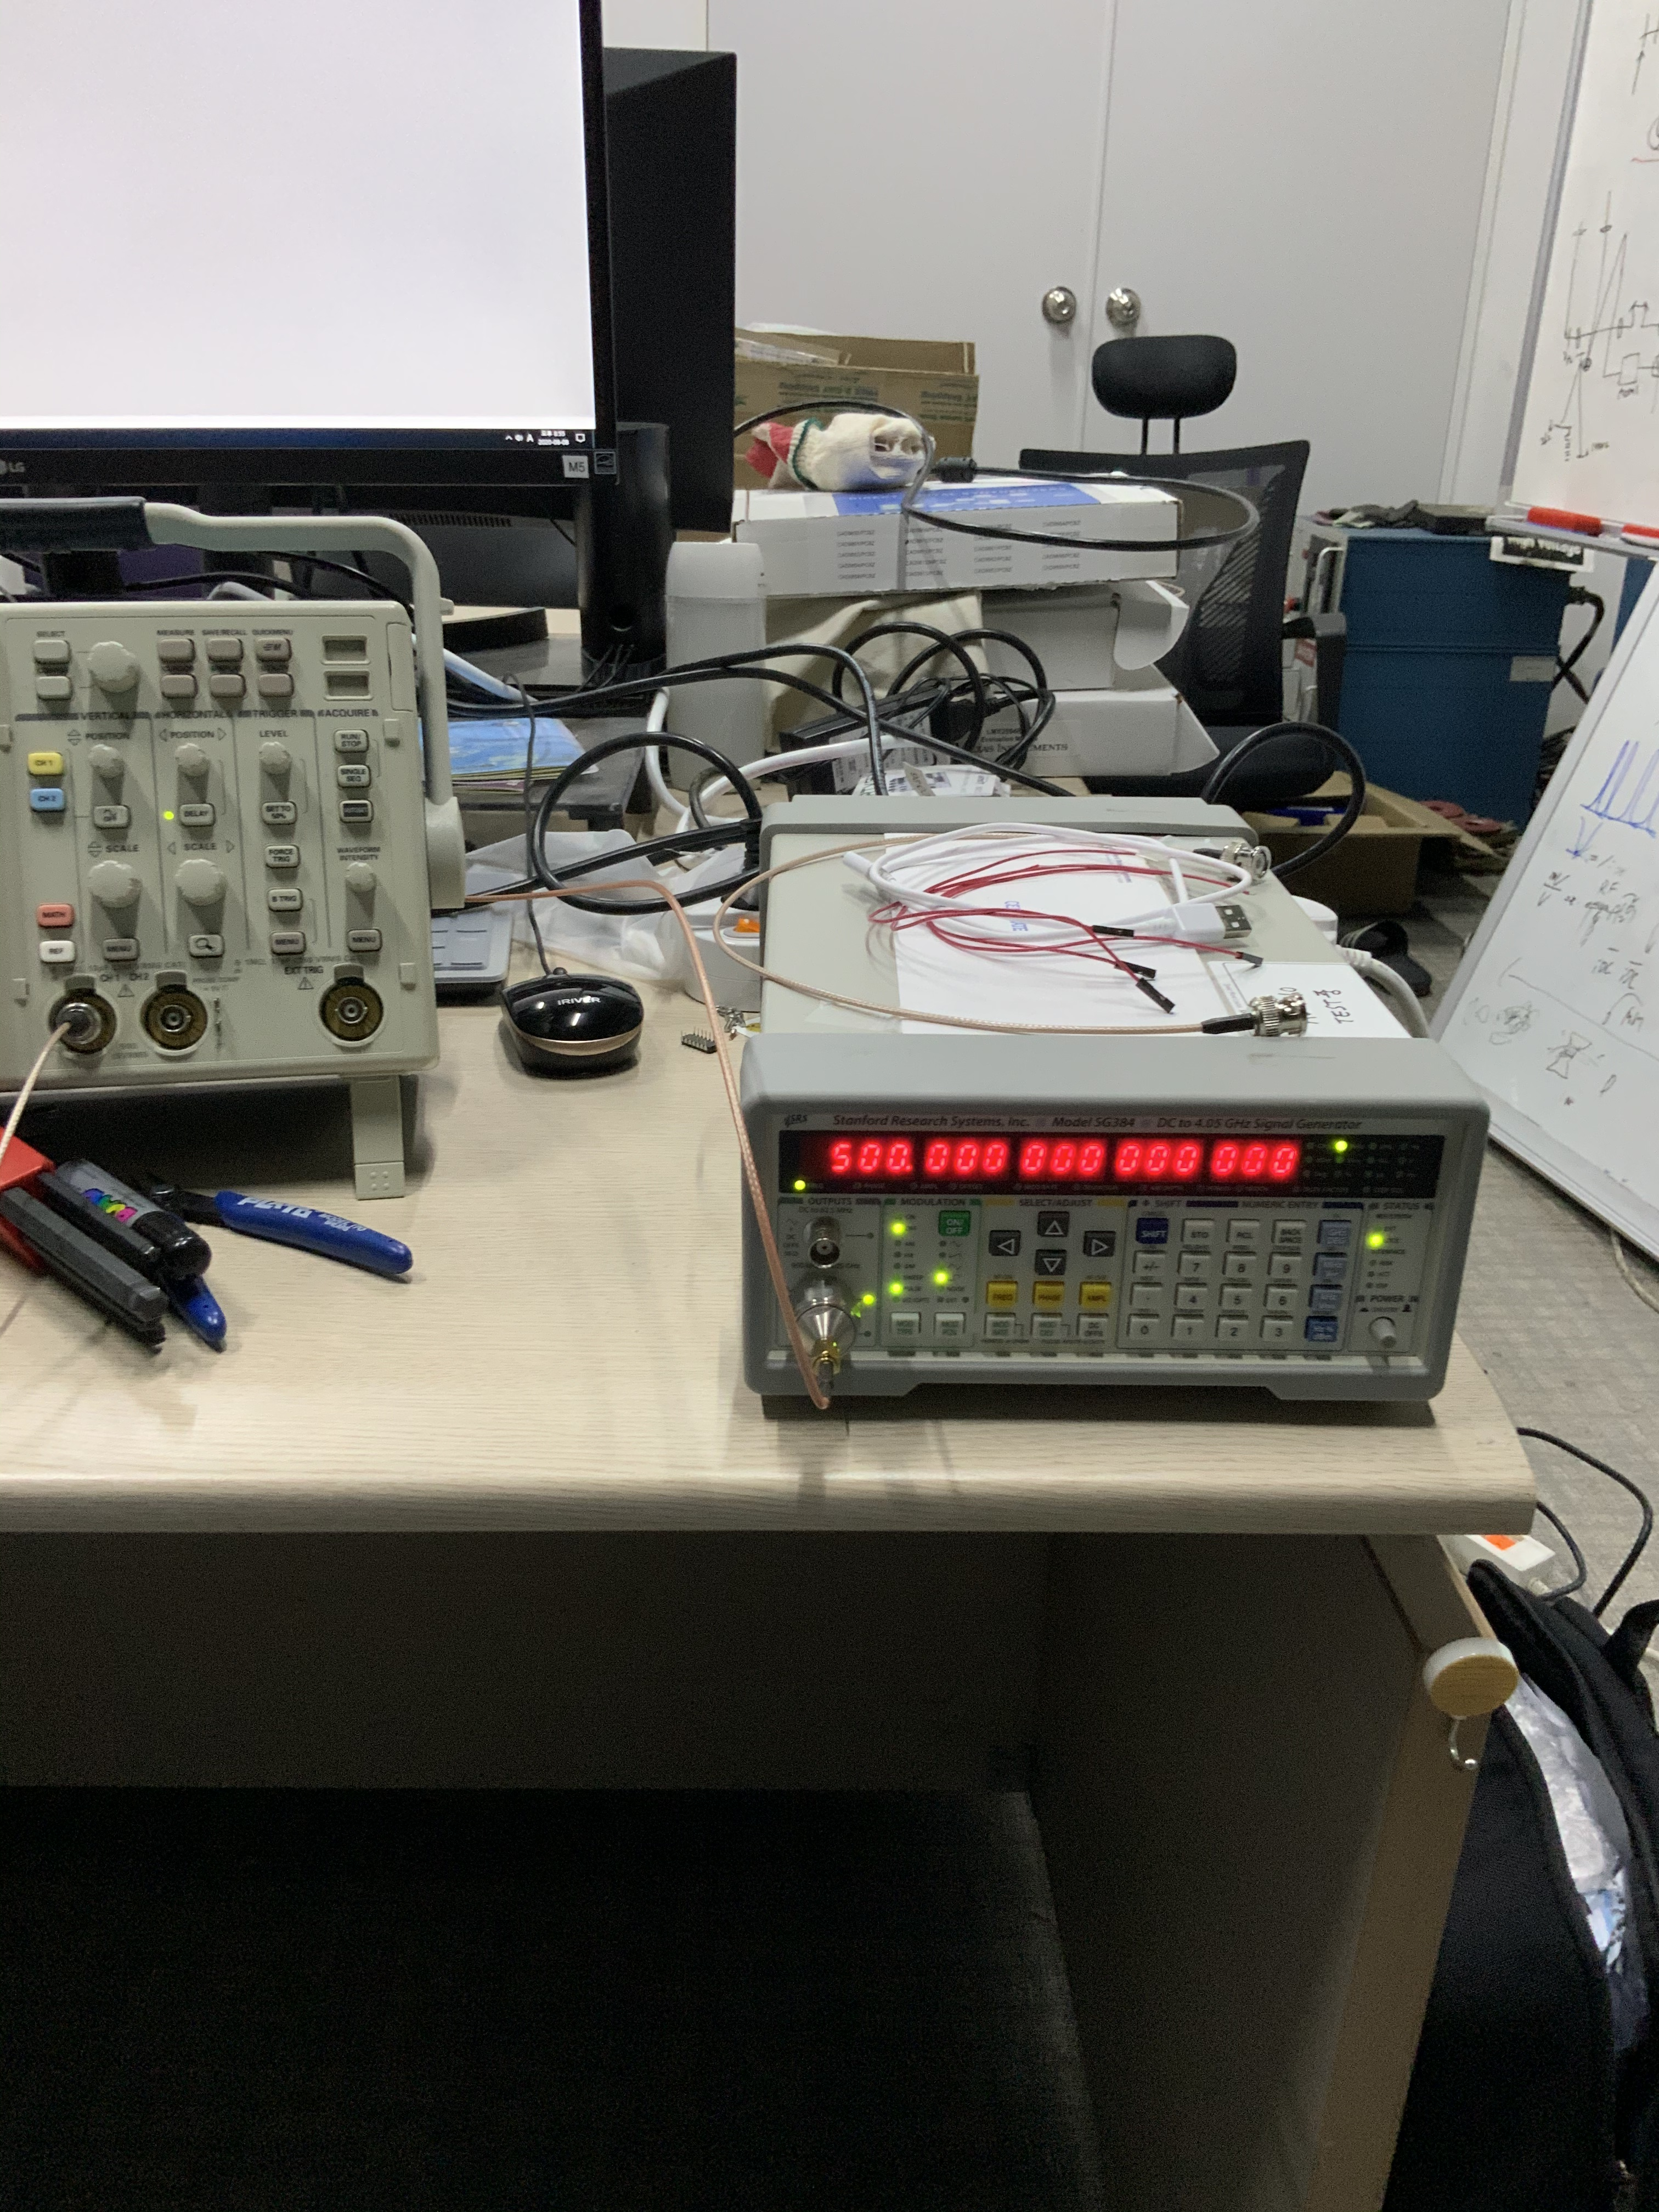

Figure. Signal generator setting. Proper signal generator output should be selected. In this case SMA output is proper output due to high output frequency

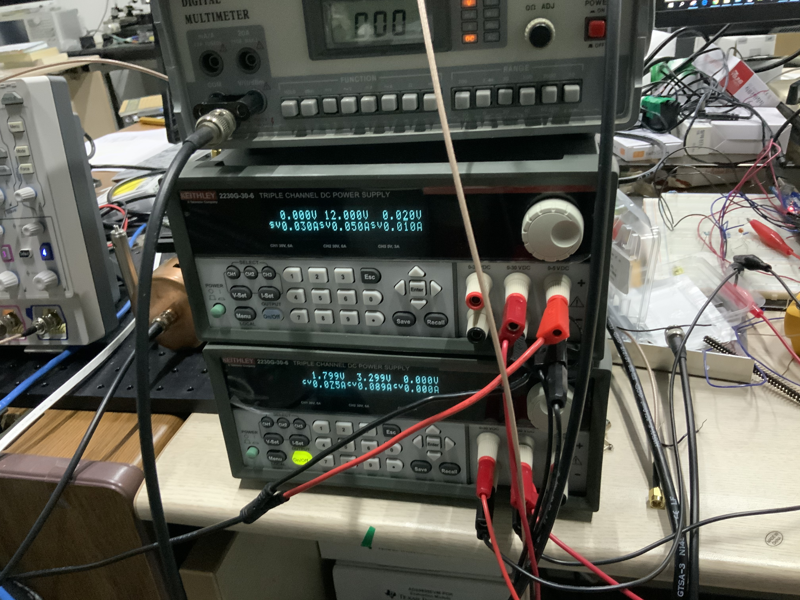

Figure. DC supply setting. If CC occurs, set proper current to DC supply. 100mA ~ 200mA will work well

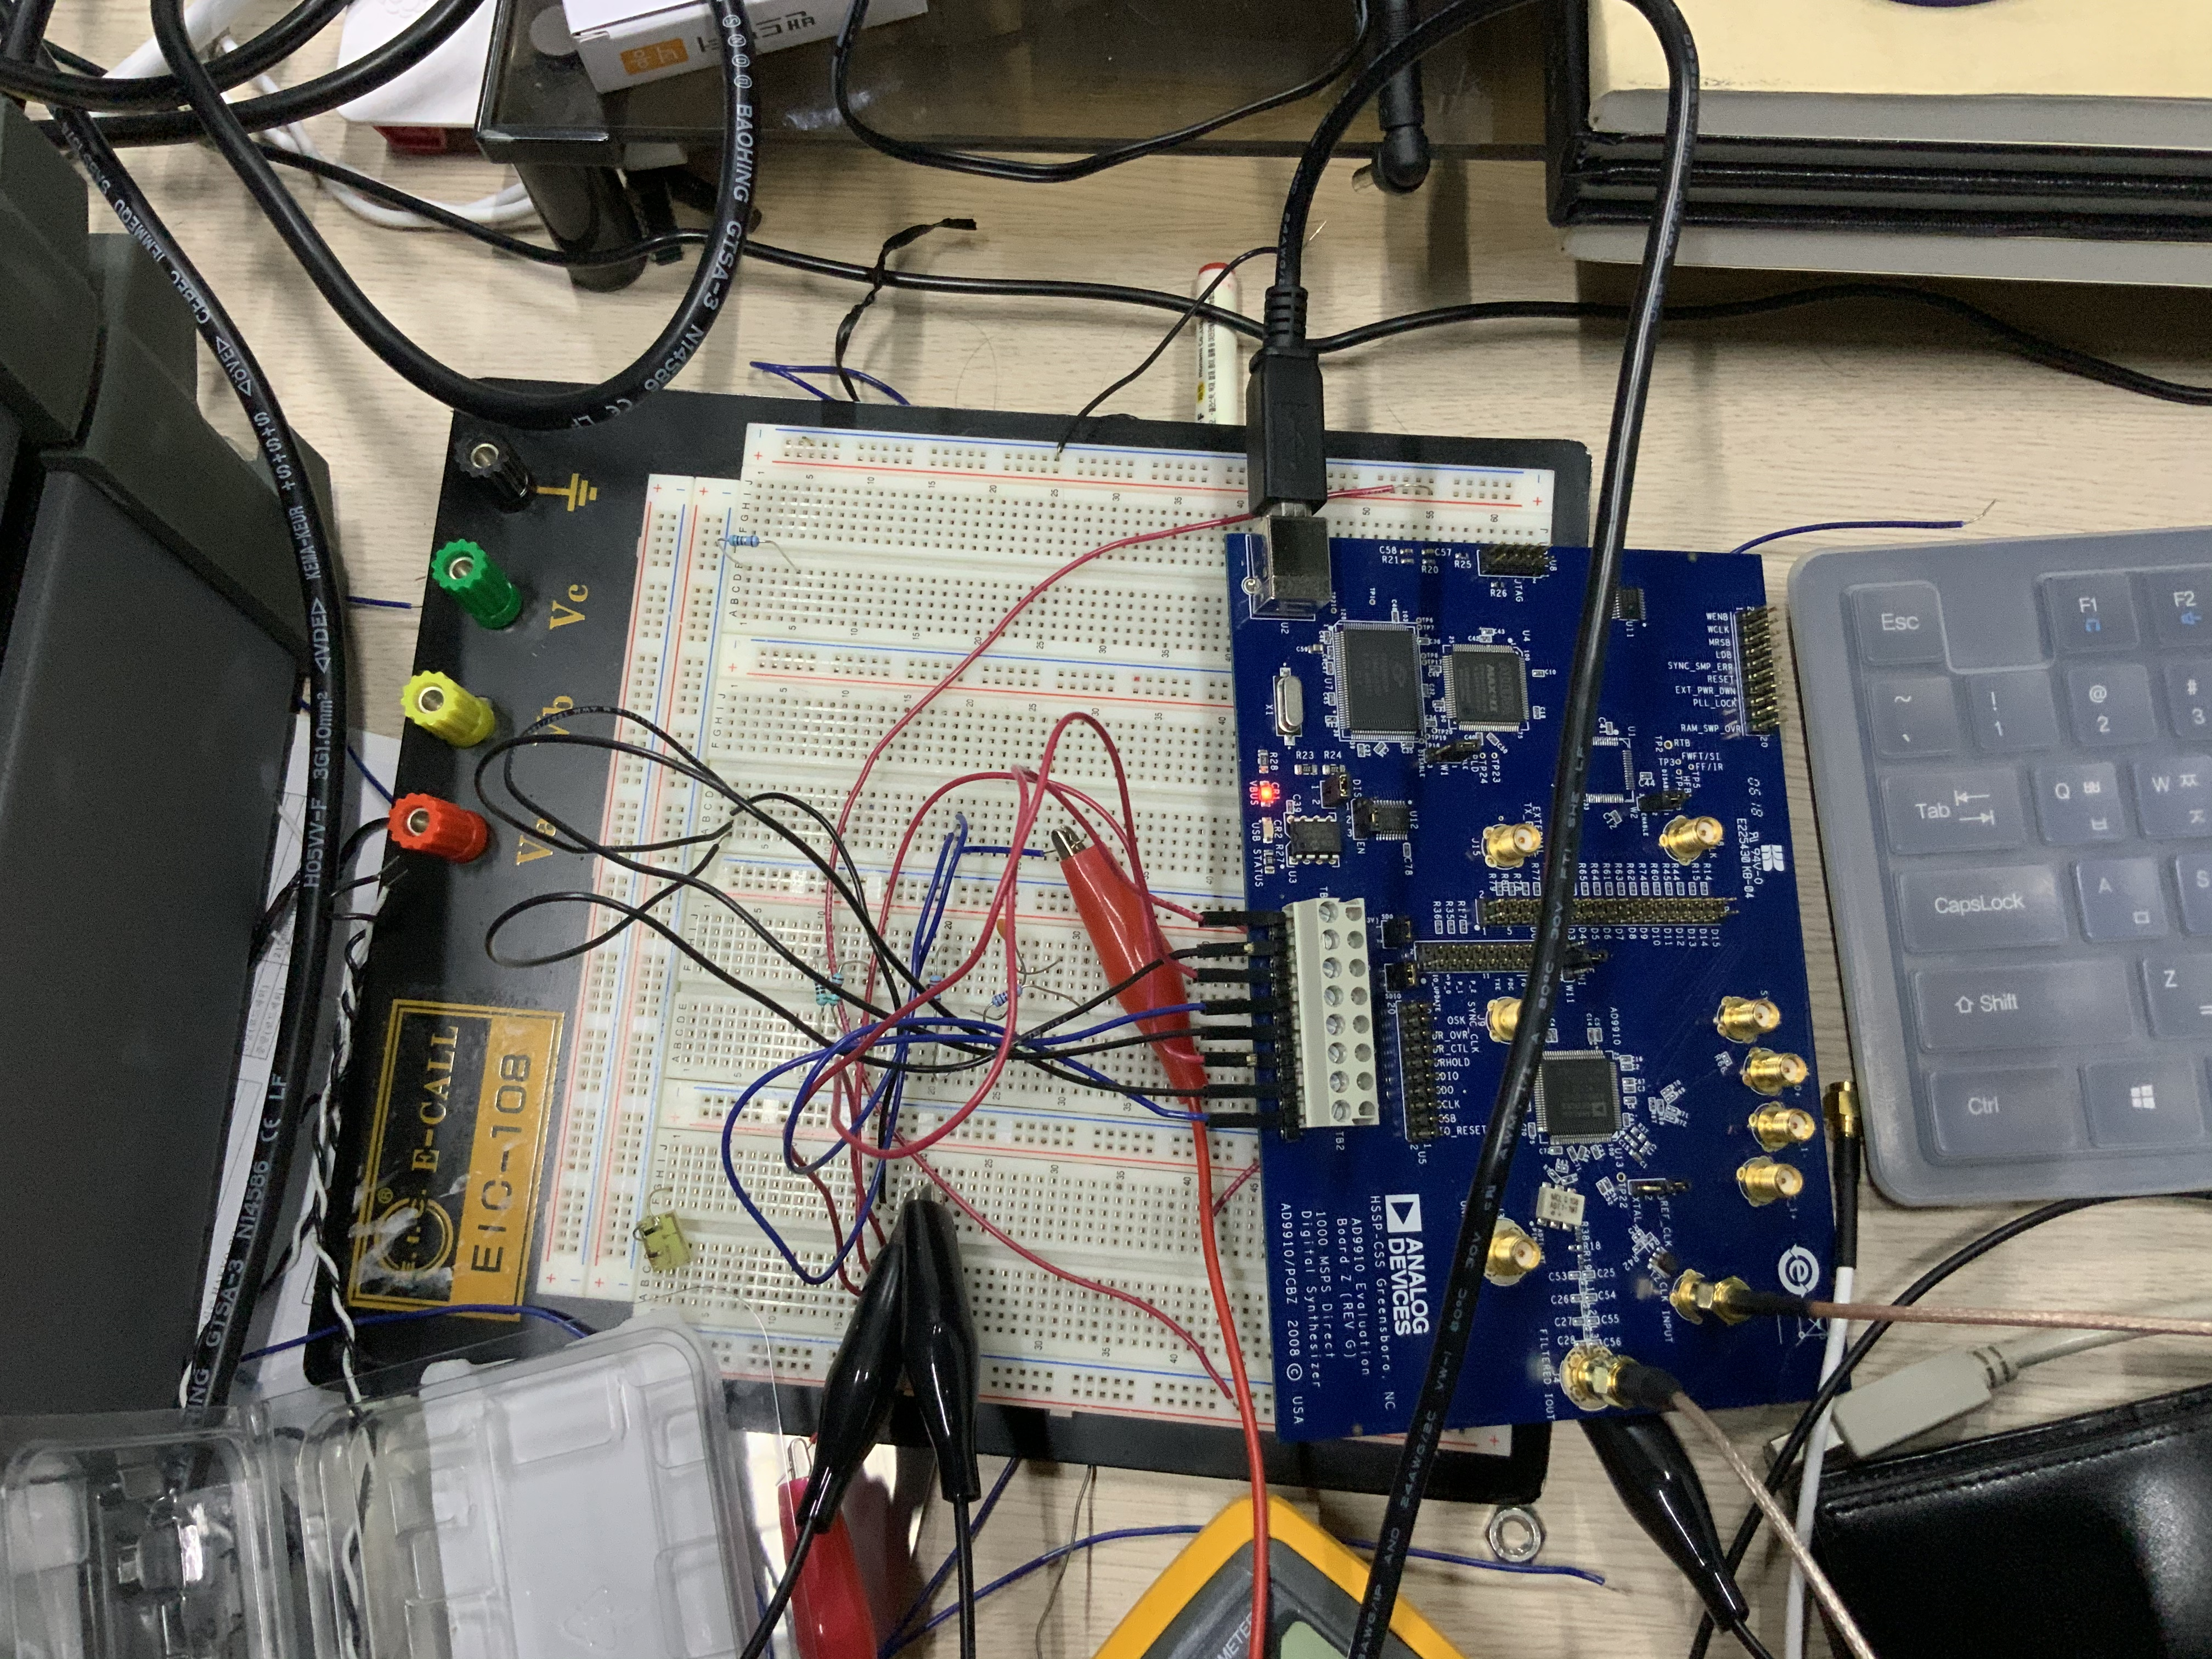

Figure. Evaluation board and DC voltage connection. If connection and jumper setting are adequate, red flash at VBUS and green blanking at USB will appear

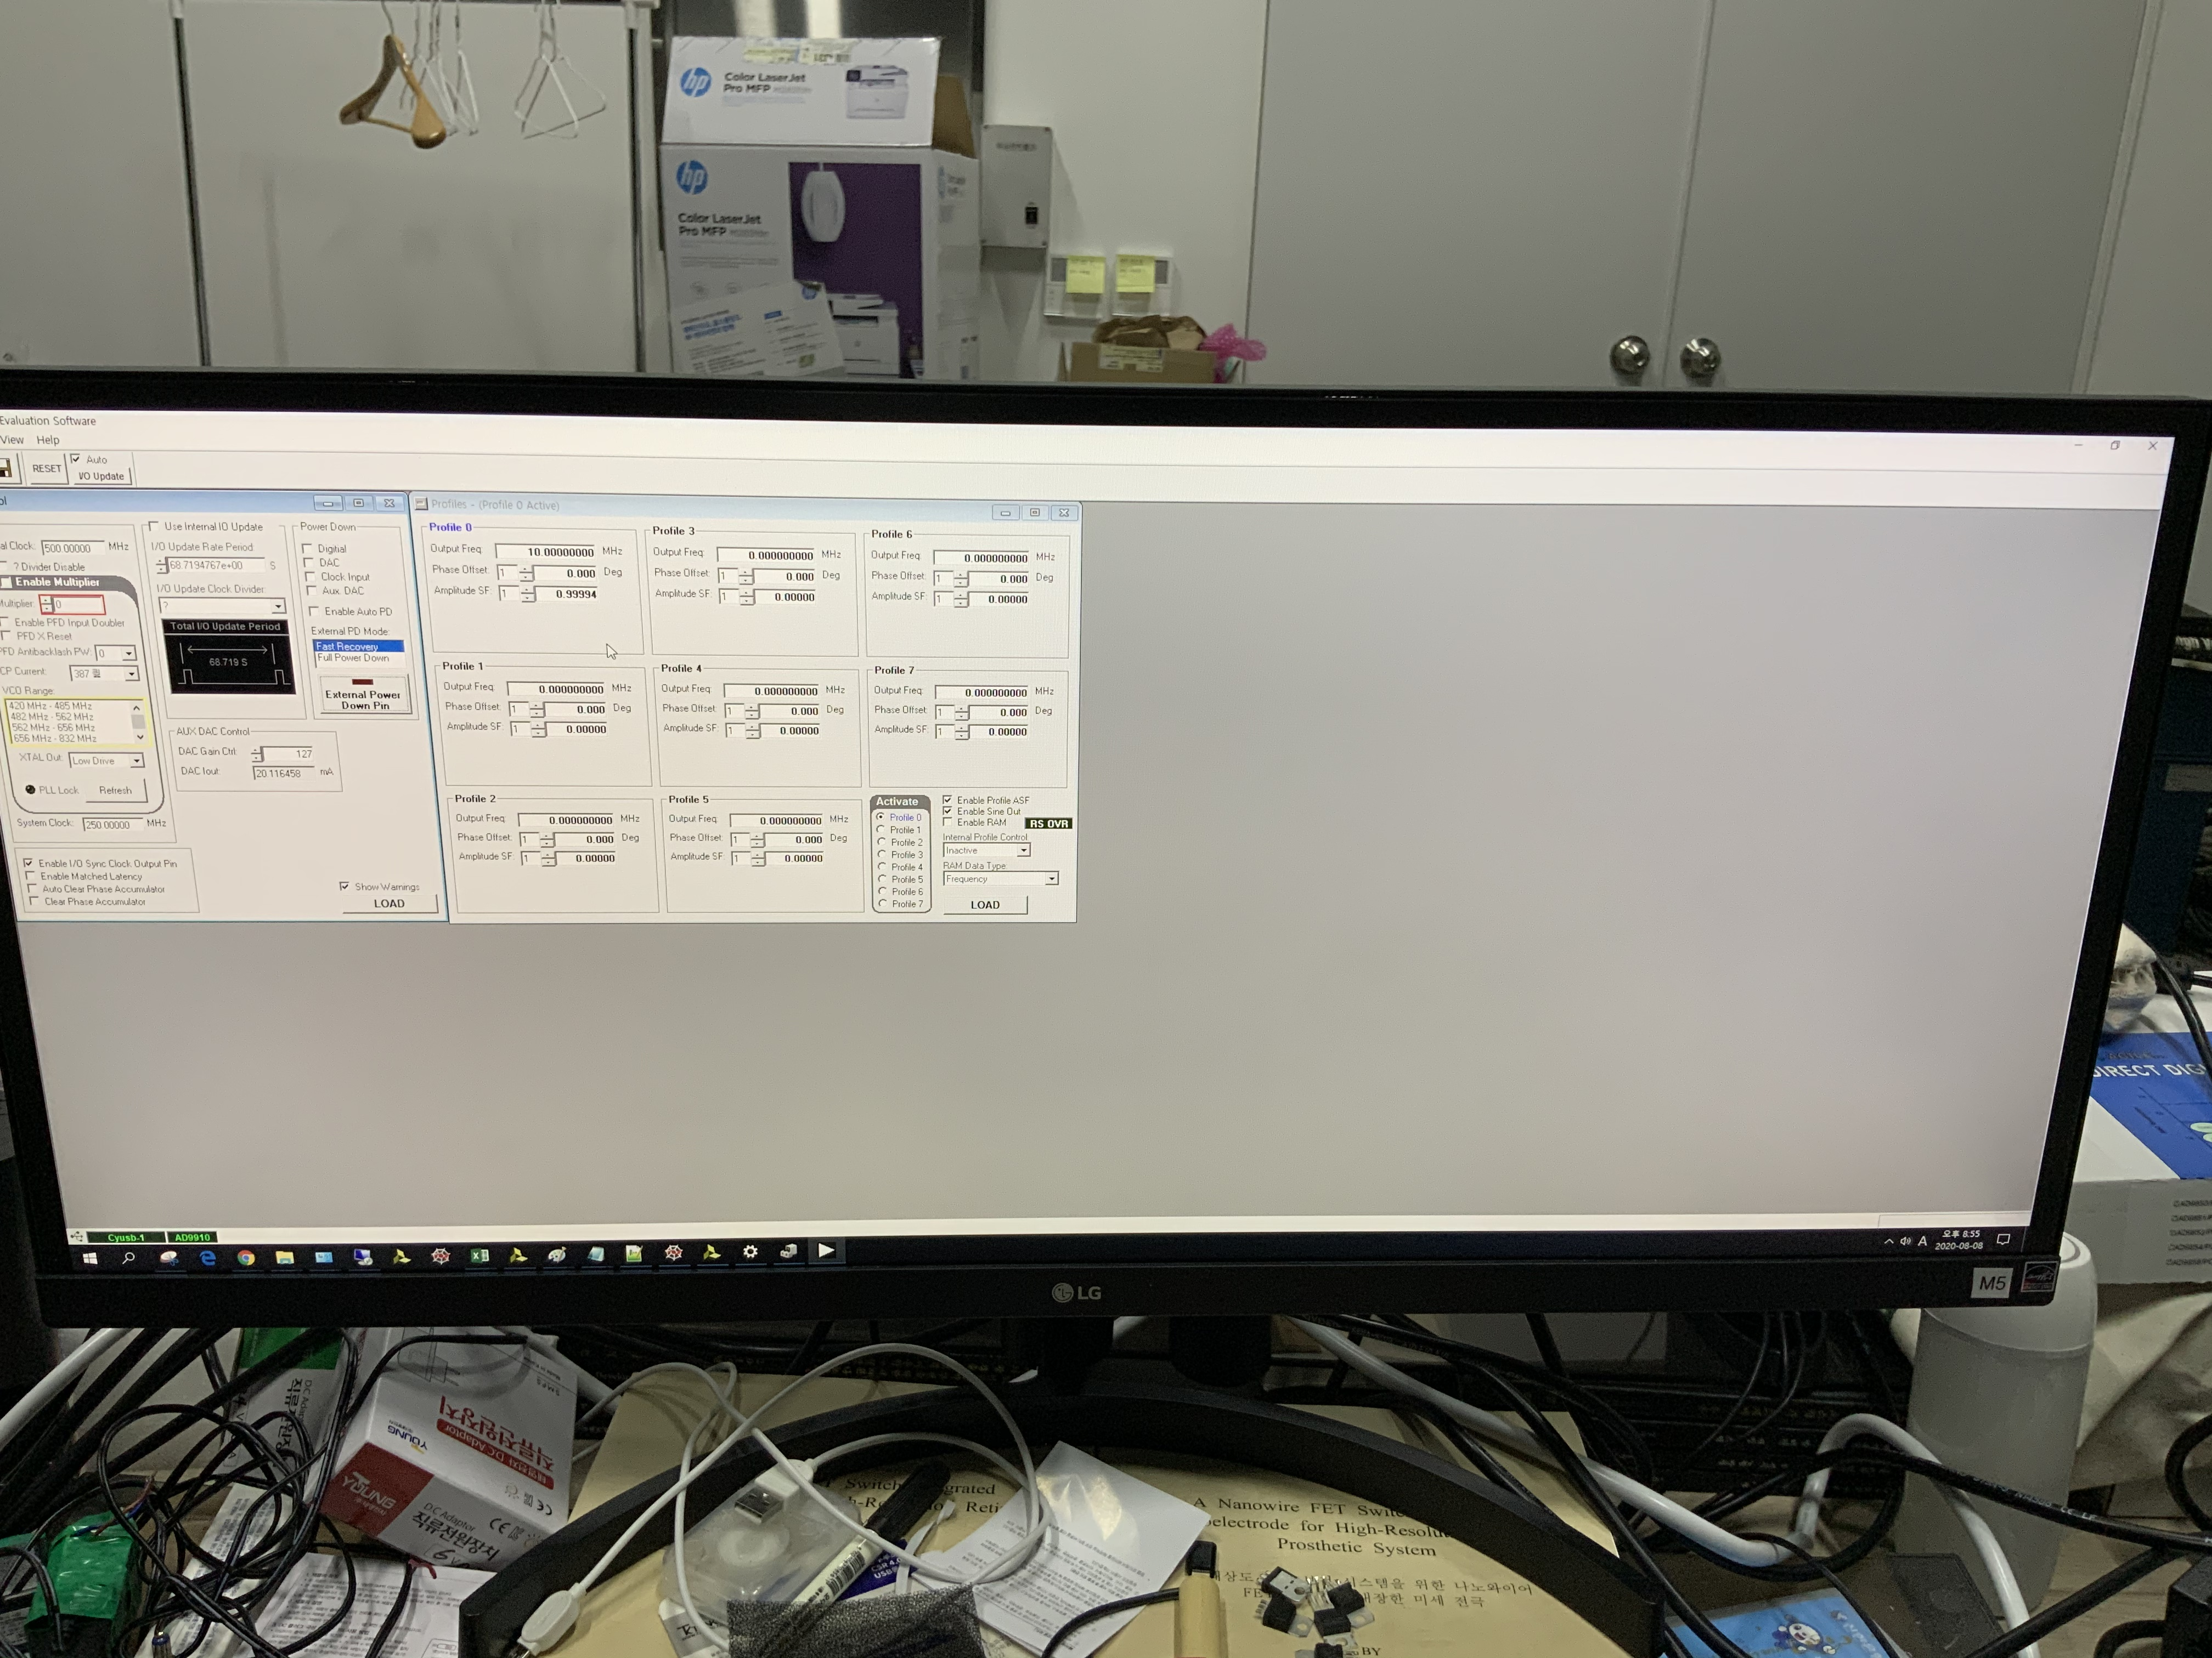

Figure. Analog program. There would be two green light left below of screen if setting is well done.

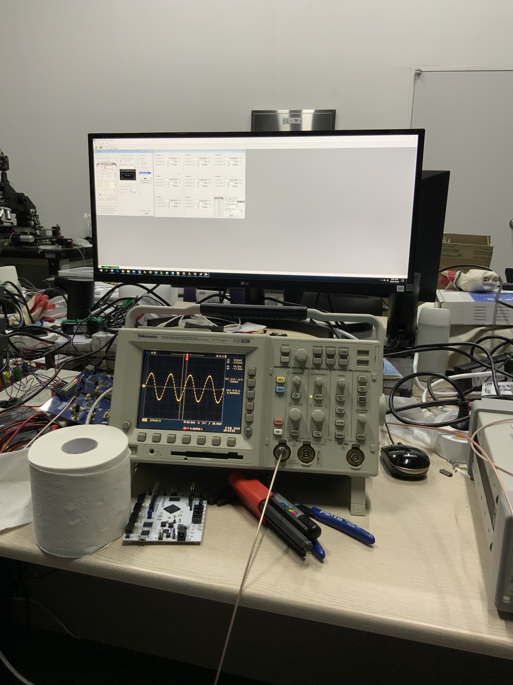

Figure. Output measurement and oscilloscope setting. Oscilloscope has internal 50 Ohm register, so direct connection between DDS and Oscilloscope don’t make problem

1.3.2.2. Using FPGA(ArtyS7)

After proper output of FPGA is measured, connect FPGA pins to AD9910 evaluation board using jumper cable(these jumpers don’t mean jumper ports of evaluation board) as follows.

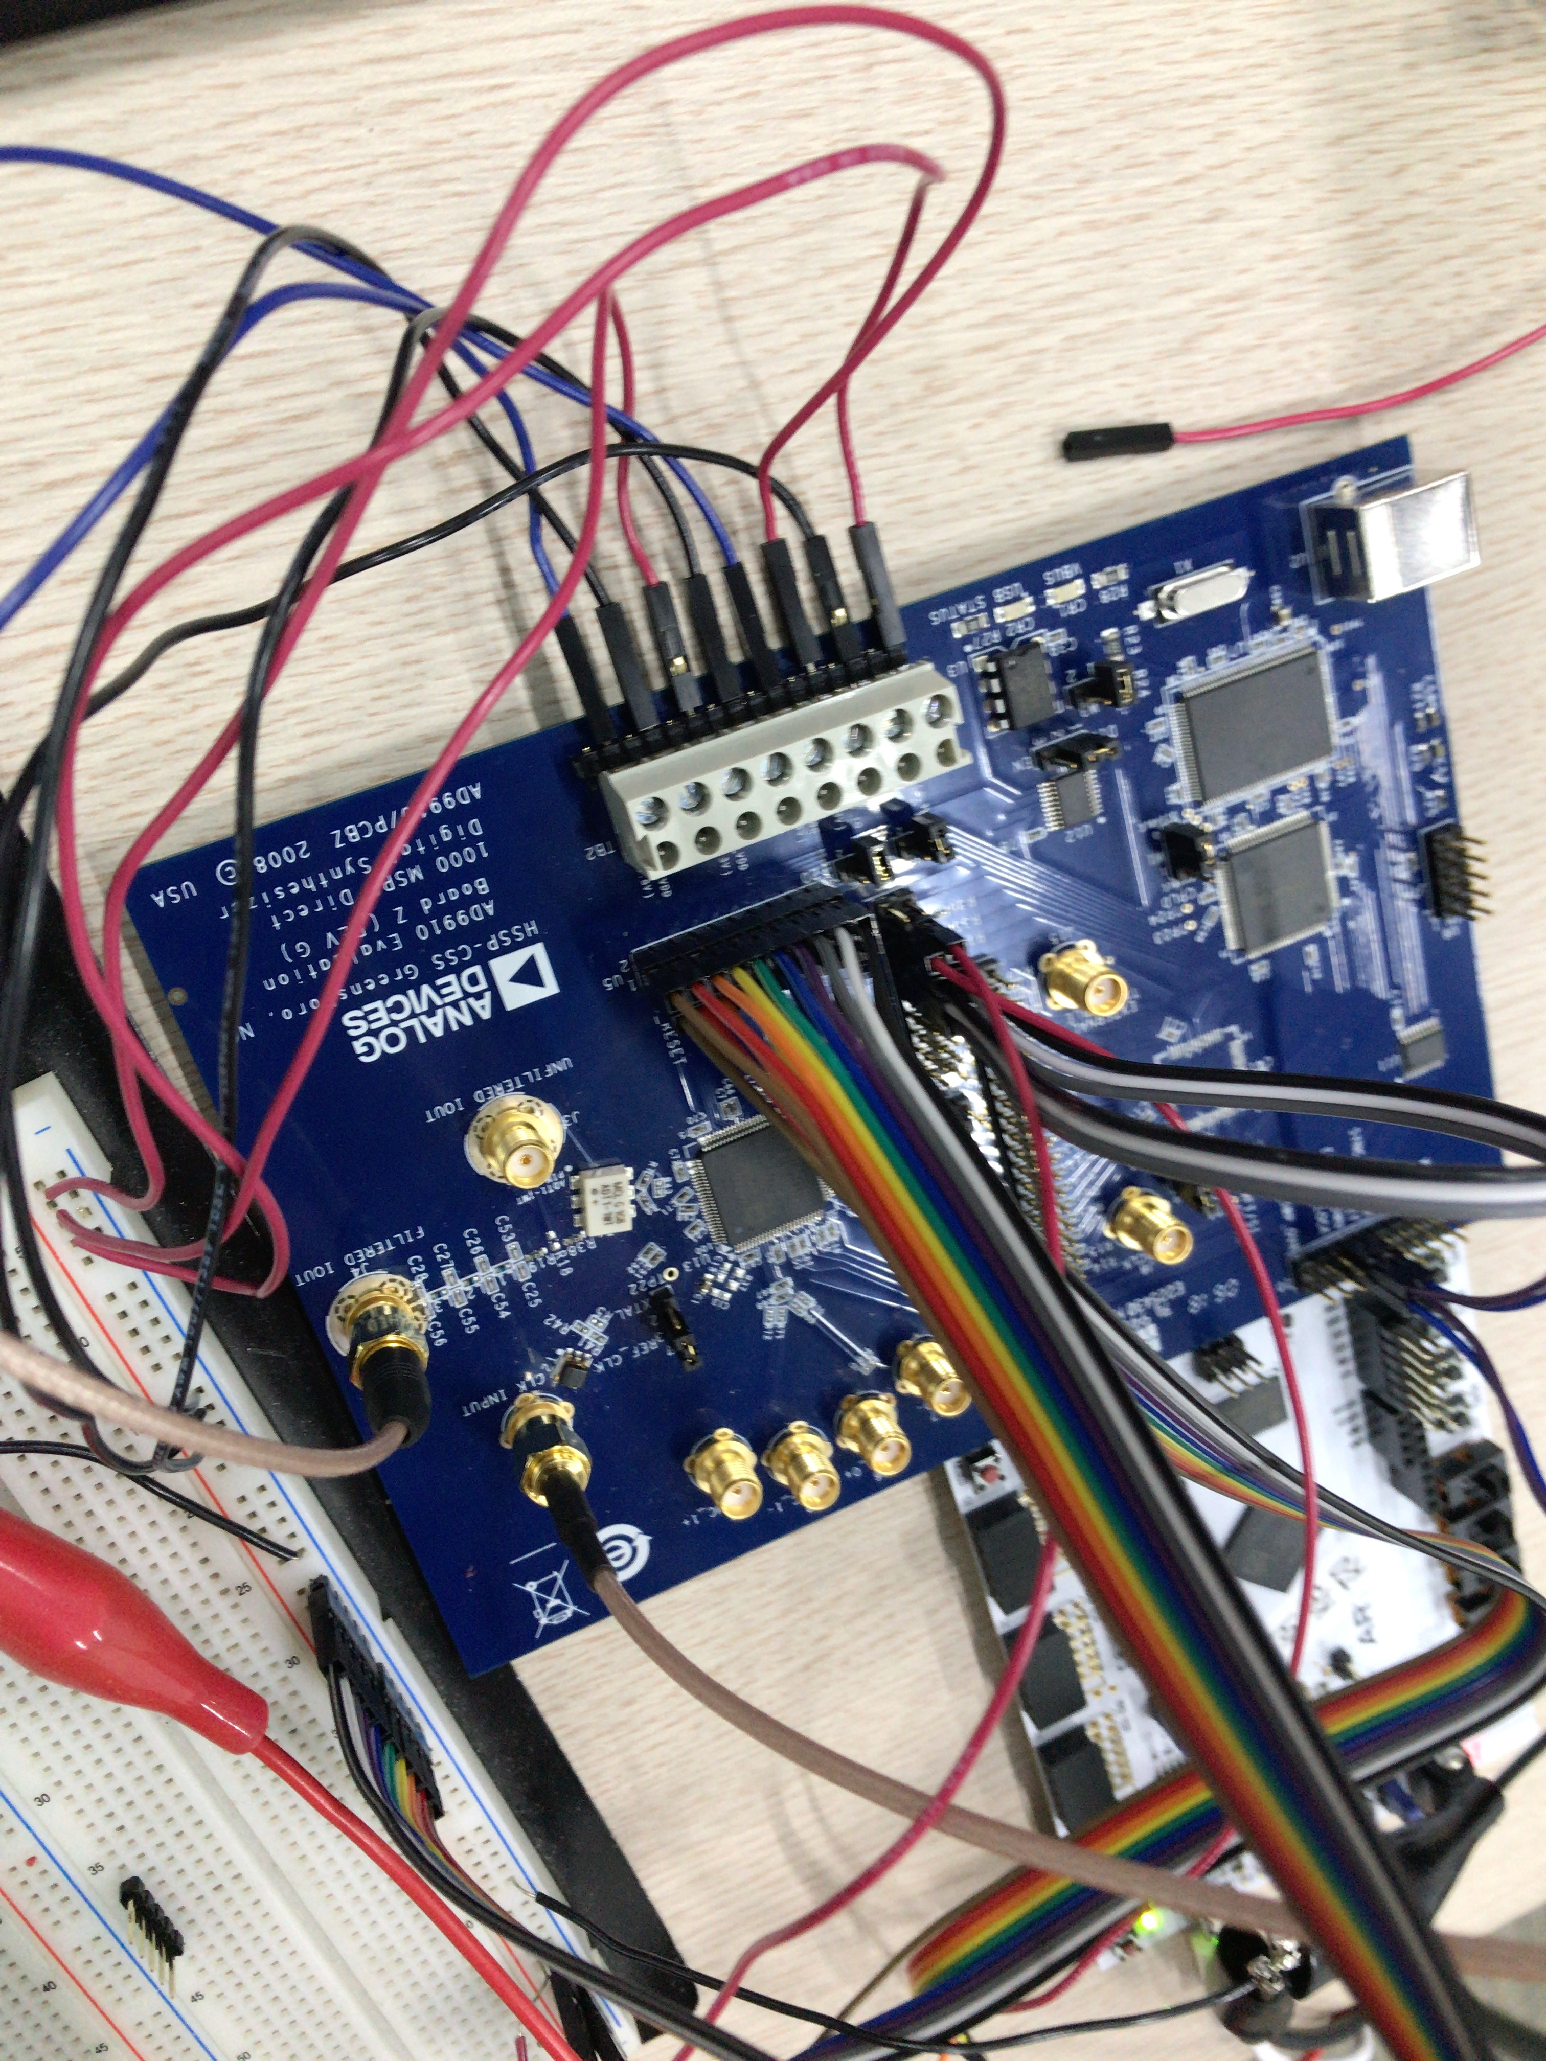

Figure. Connection between U5 and FPGA. Jumper connection should be changed when DDS board is controlled through FPGA. In this test, single tone mode is implemented and only profile0 is used, so profile pins should be connected to ground.

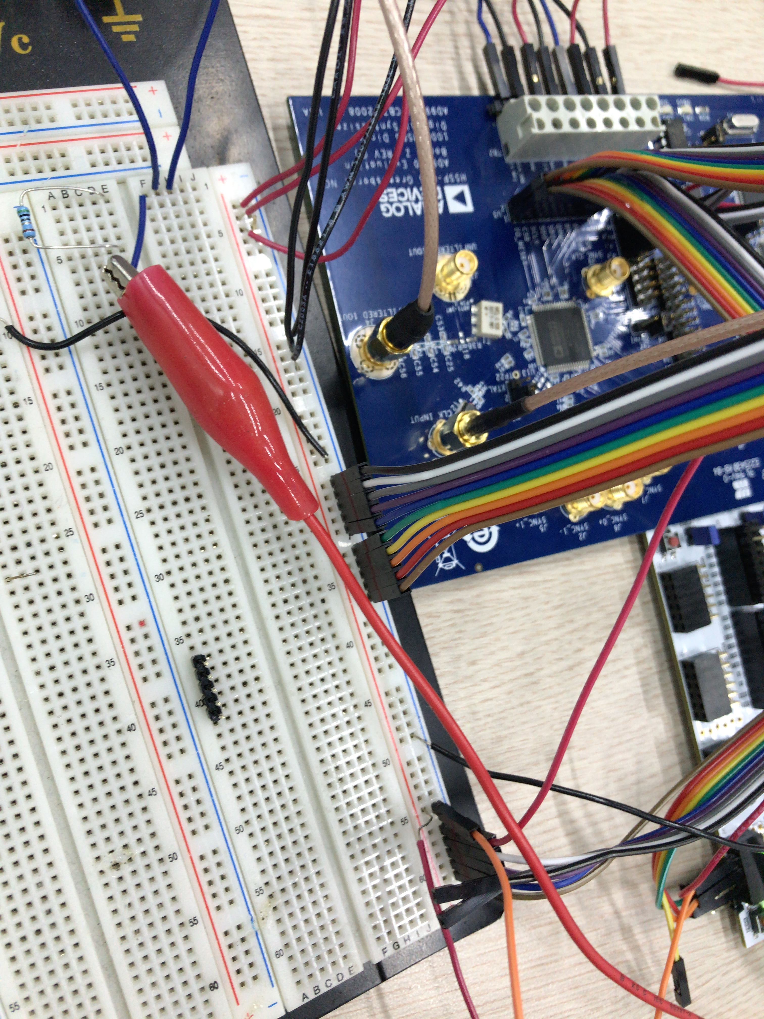

Figure. Connection between DDS and DC power supply ground.

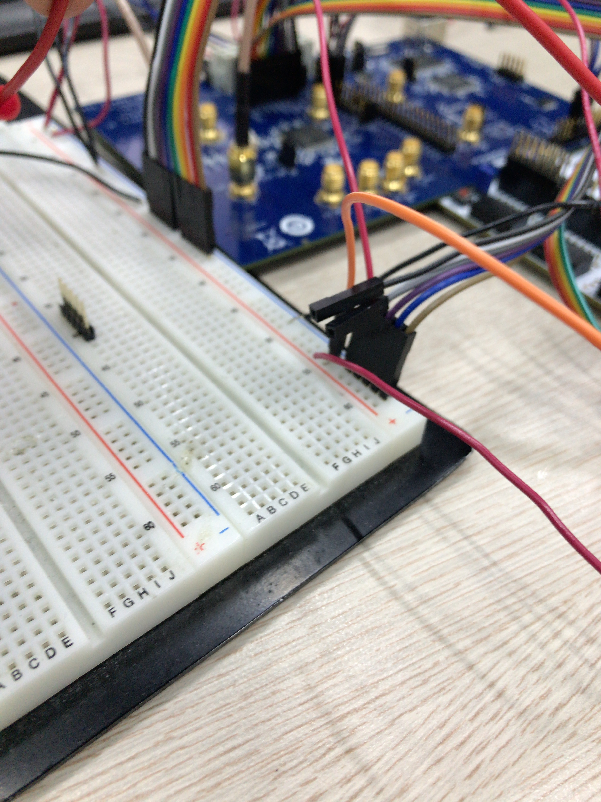

Figure. Connection between DC power supply and evaluation board pins. Only SDIO, SCK, CSB pins in U5 are connected to FPGA, other input pins(OSK, DR_CTL, DRHOLD, IO_RESET, SDO) are connected to ground. The others (DR_OVR, SYNC_CLK) is not connected.

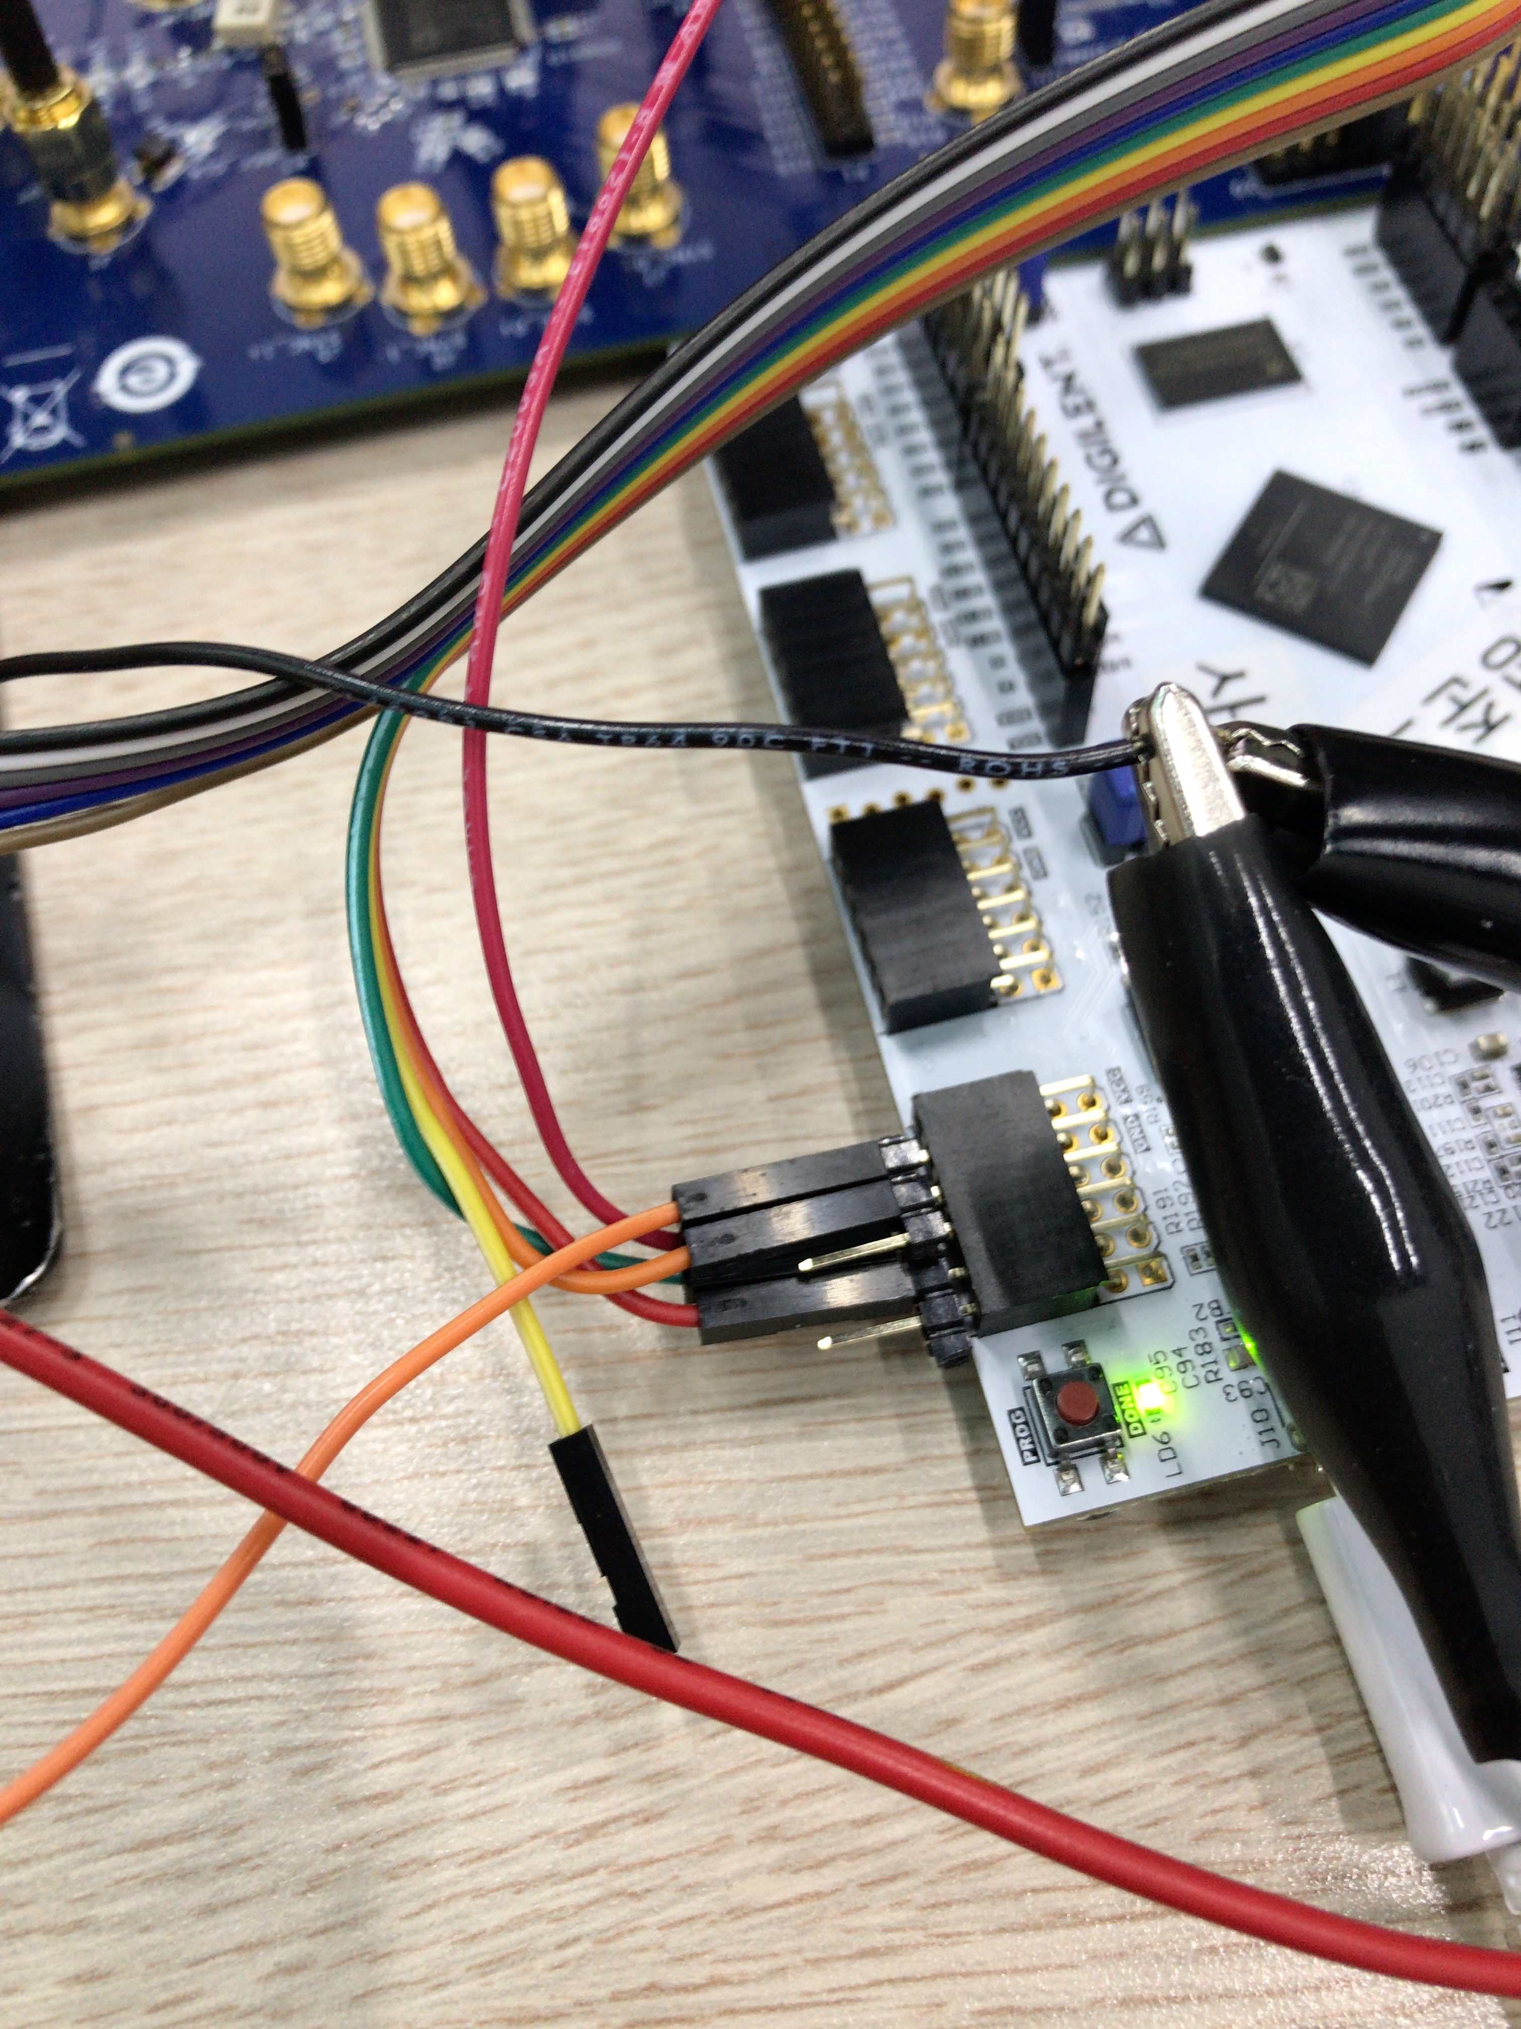

Figure. Connection between FPGA and evaluation board. Only DDS1 port is used in this test.

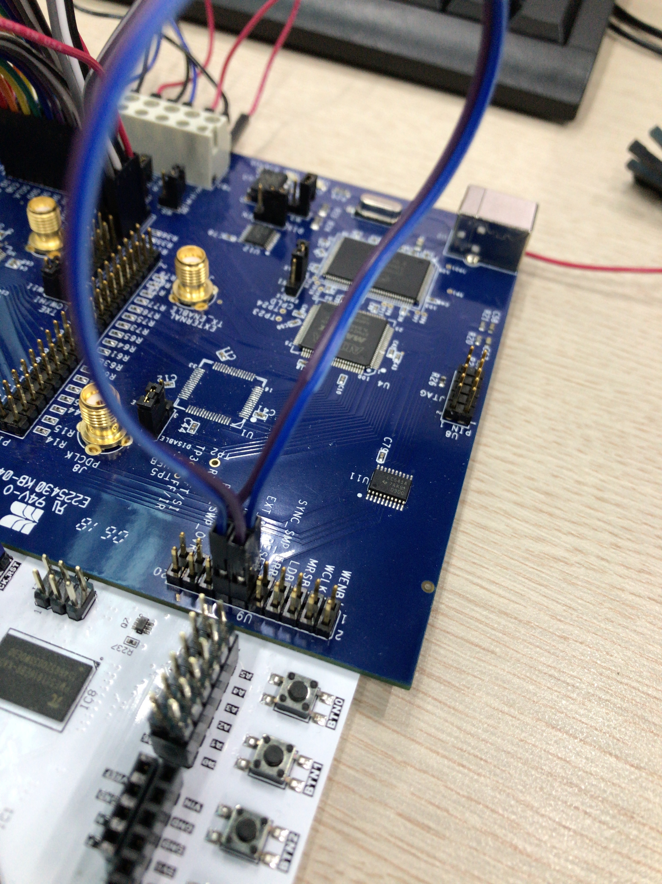

Figure. Connection in U9. RESET and EXT_PWR_DWN should be connected to ground.

Same signal generator, and DC supply setting are used except 1GHz output frequency of signal generator, and jumper setting of evaluation board. W1, W2, W4 jumper should be set to DISABLE, and W5, W6, W3 should be removed on the evaluation board. W7 should be set to REF_CLK(since signal generator is used for reference clock) and W11 pin to middle(since TXE pin was not used). You should connect 4 pins(IO_UPDATE, CSB, SCLK, SDIO) to FPGA(JA7, JA6, JA5, JA3). And other pins in U5(IO_RESET, SDO, DRHOLD, DR_CTL, DR_OVR, OSK, SYNC) should be connected to ground. In this test only single tone mode was implemented, so profile pins in P1 should be connected to ground. And EXT_PWR_DWN, and RESET pins should be connected to ground. And connect oscilloscope and DDS board using SMA to BNC cable. To see simple output of DDS, turn on AD9910_EX.py and implement 6, 5, 7, 5, 8, 5, 4 functions orderly. Notice that 6, 5, 7, 5, 8, 5 functions corresponds to initialization of CFR1, CFR2, CFR3 register and sending IO UPDATE signal to update register of DDS. If CFR setting is not conducted, there would be half of output frequency due to bypassing option of CFR. And implementing function 4 corresponds to setting register of profiles. If other profile which is fixed by connection on the evaluation board is set in this test, DDS output frequency would not be changed. And setting frequency, phase, and amplitude using [1], [2], [3] function will not work because these does set FTW, POW, ASF register which are not profile register. FTW, POW, ASF works when only using RAM, DRG, and Parallel mode.

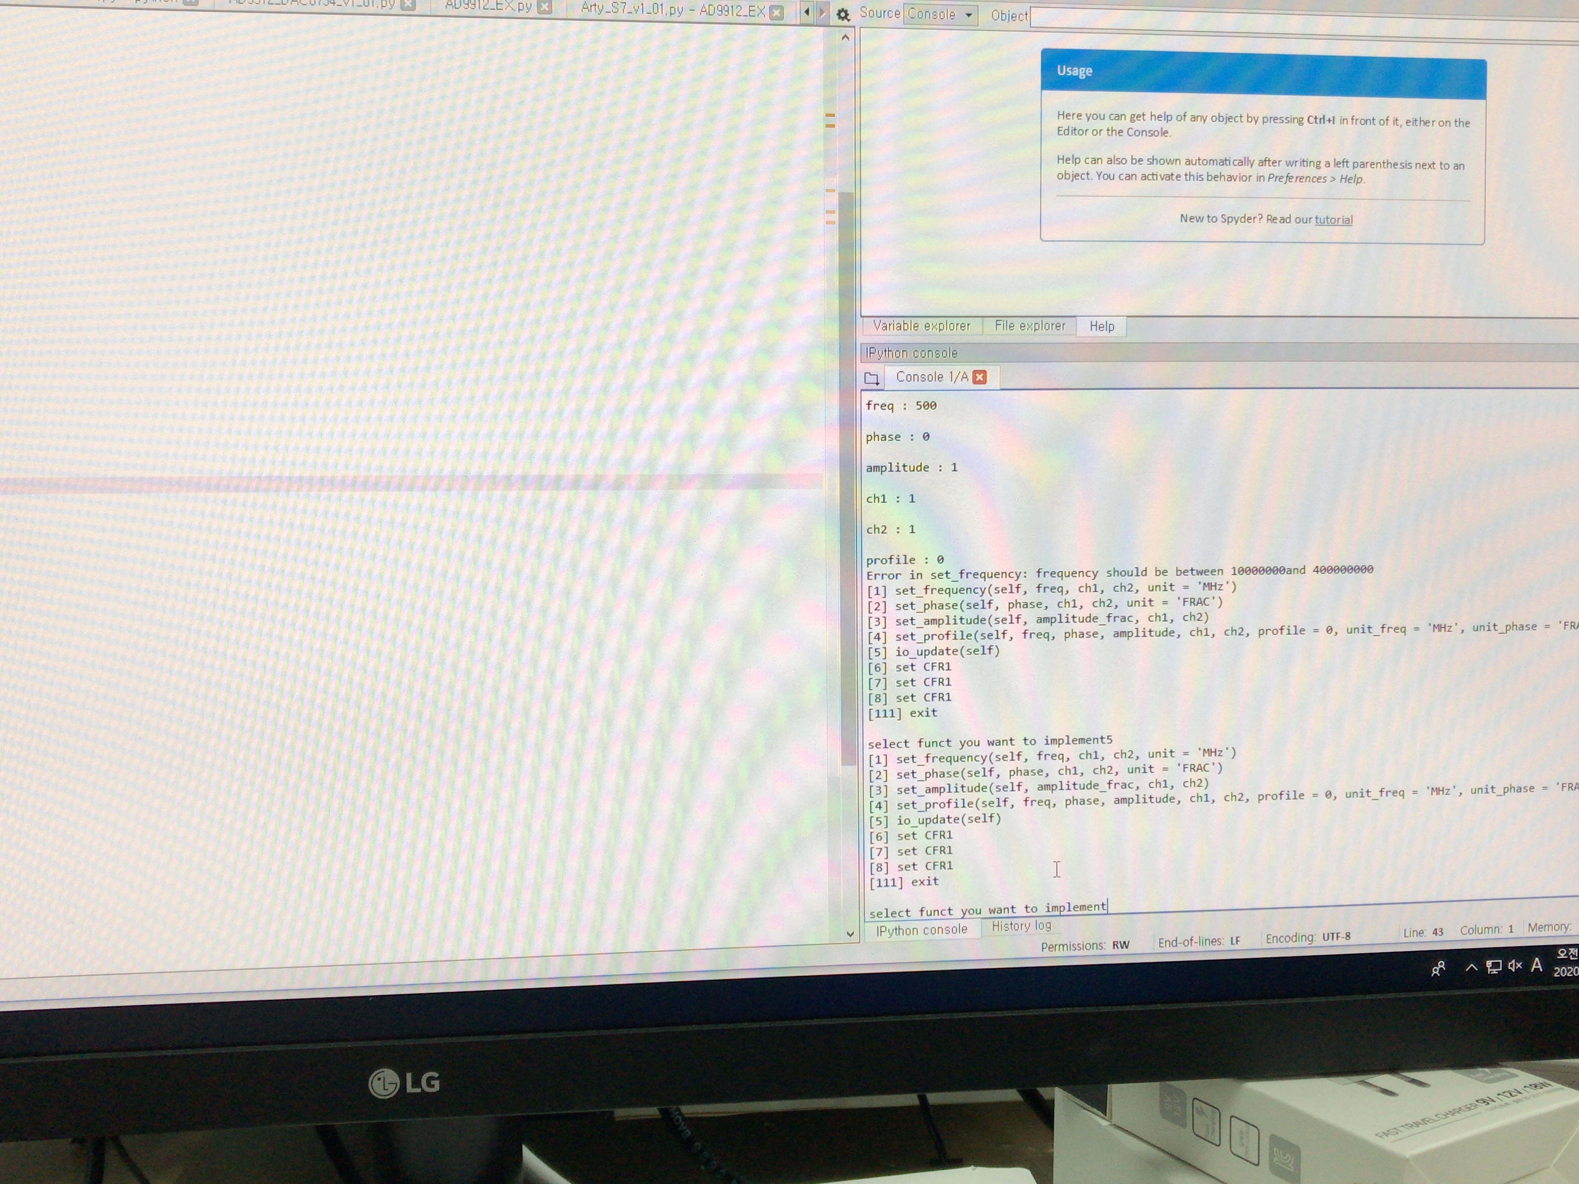

Figure. Python program

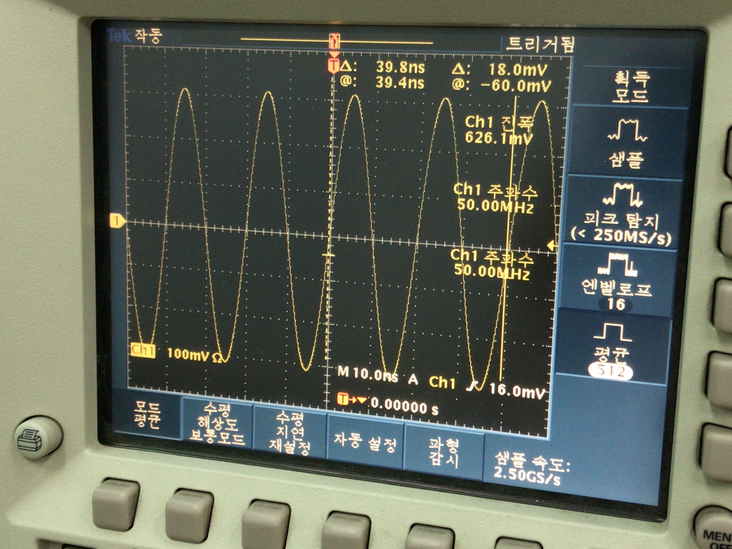

Figure. Output measurement

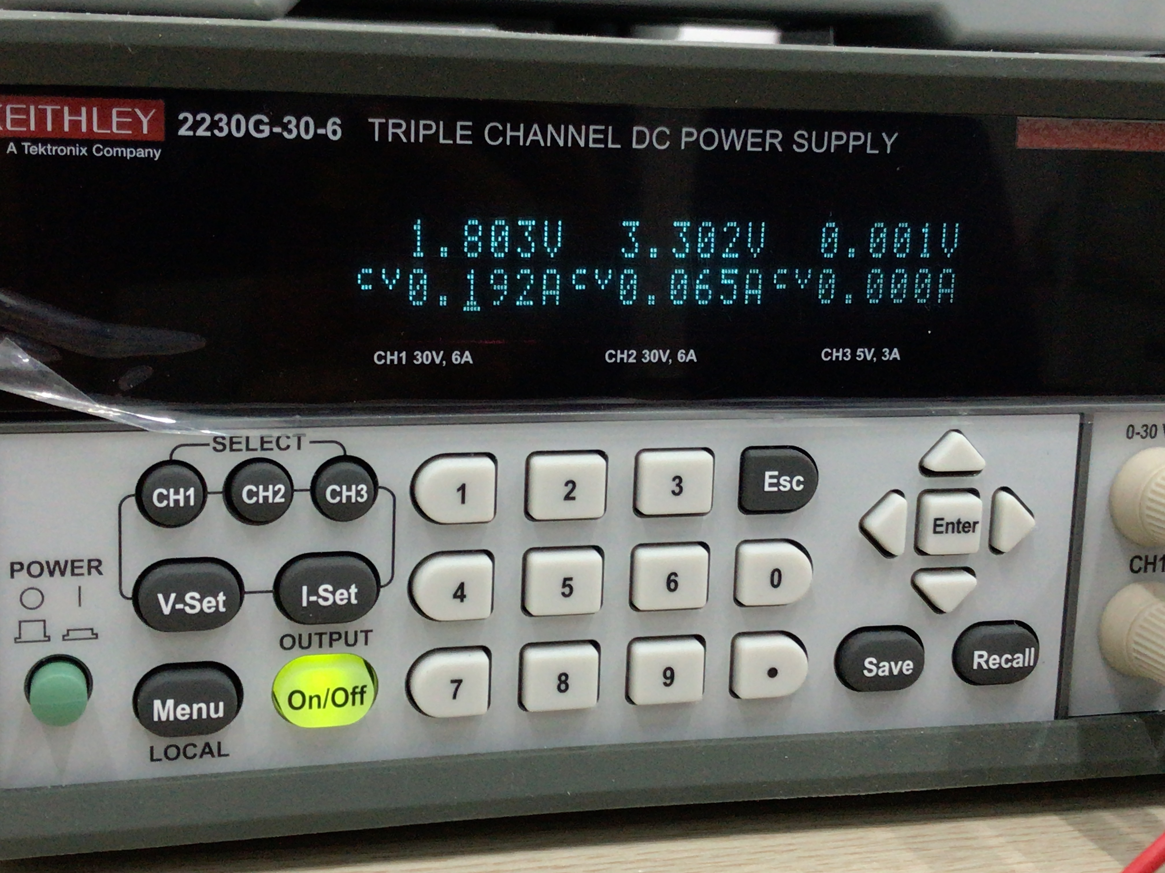

Figure. DC power supply setting. If maximum current is set too low, output of DDS would not be clear.

2. New Design

2.1. Modified Architecture

New hardware architecture was made applying new design of sequencer and maintaining previous AD9912 FSM. Main differences of this design are FIFO which discharge instruction at stated timestamp, gpo core and rto core which are based on new design of sequencer, and removal of DAC modules and WRT modules. DAC modules and pins were removed since DAC pins were replaced to AD9910 parallel output. jb. jc pins were also activated to supply signal of profile and rest of parallel output. WRT module was replaced to new spi module which can set CPHA, CPOL, CSPOL, slave enable, length of signal, cs, whether to end SPI, LSB_FIRST, and clock divide. So any SPI mode can be implemented. And, depending on slave enable DDS register can be readed. 32 bit, 64 bit wirte, read function is implemented on AD9910.py. Additionally, override function is implemented so driving FPGA without FIFO is possible. Notice that when python code is modified, notice that WRT is removed and length of SPI data is set in SPI configuration, so length of data is not included to BTF_list(so 64 bits needs list of length 8, and 128 bits needs list of length ). Moreover, BTF_list should be composed in little endian. For example, 0x0123456789ABCDEF should be converted to [EF, CD, AB, 89, 67, 45, 23, 01].

There are some difference with new sequencer. First sequencer is implemented based on memory mapped IO, while this is not. However, memory mapped IO can be easily implemented adding some register outside of gpo_core, rto_core, rti_core. In addition, sequencer use 32 bit data transfer while this uses 128 bit and 64 bit. Second, there are error signals which discharge pulse and error dat. Error signals are overflow error, timestamp error, overrided, busy error, underflow error. Overflow error indicate that fifo in rto_core or rti_core is in overflow. And error data corresponds to data which is not written to fifo due to full of fifo. Timestamp error indicates that timestamp of data in the top of fifo is less than counter. Error data corresponds to this top data. Overrided indicates that override value and fifo output came from input coincidently. Error data corresponds to fifo data, and override value would be discharged from gpo_core. Busy error indicates that new income arrived while output port is in busy state. In this case error data corresponds to new income, and output of gpo_core would not be changed and selected pulse would not be made.



Figure. New pin arrangement. IOBUF was used to make read possible



Figure. Architecture of AD9910 driver



Figure. Mircoarchitecture of gpo_core_prime and rto_core_prime



Figure. Mircoarchitecture of rto_core_prime



Figure. Mircoarchitecture of gpo_core_prime



Figure. Mircoarchitecture of rti_core_prime



Figure. Mircoarchitecture of gpi_core_prime

2.2. Modified Function

Python code was modified due to new design of hardware. Previous python code use fixed length (9 times 8 bits) when using send_mod_BTF_list, however new python code use 8 bytes in override mode, and 16 bytes in auto mode. These mode can be set using function ‘auto_mode()’ and ‘override_enable()’ each. In the same way each can be disabled using ‘auto_mode_disable()’ and ‘override_disable()’. In auto_mode, timestamp will be added to instruction according to time value in AD9910 object. Time value can be shifted using ‘delay_cycle(shift_time)’ and ‘delay(shift_time)’ function. Notice that ‘delay_cycle’ function makes shift of unit in machine unit while ‘delay’ function makes shift of unit in second. For example, delay_cycle(10) is equal to delay(100*ns) since one cycle is equal to 10ns in ArtyS7. And, using function of AD9910 would not change time value, so you have to consider set proper time delay not to make busy error or timestamp error.

Previous AD9910 code uses parameter unit to indicate which unit is used in frequency, phase etc. However in new code, you don’t have to consider about this, and write proper unit and asterisk(‘*’) next to number like in ARTIQ. For example, 100 MHz can be written as ‘ 100 * MHz’. Available unit is written in unit_set.py so importing unit_set.py is necessary.

2.3. Simulation on Verilog

In Arty_S7_v1_01.py, there is TEST variable which indicate whether program is used for simulation not implementing serial communication or real experiment. If TEST is set to 1, value which would be discharged from PC would be printed on screen, so simulation using Verilog module is possible. Notice that UartRx is set to high before any data sent, and become low for 17361 cycles (according to baudrate set to FPGA) and data sent to FPGA. After 8 bits of data is sent UartRx should be set to high for 17361. Notice that proper time to see available output is almost 50ms, and it would takes some time(2~3 minutes).